Aimar created a rock paper scissors program, using for It lists and random integers.

If the users answer were to be the same of the program's the output would be "tie"

For each round a value Will be aded to a variable that Will be shown in the end of the execution

aimaren partia :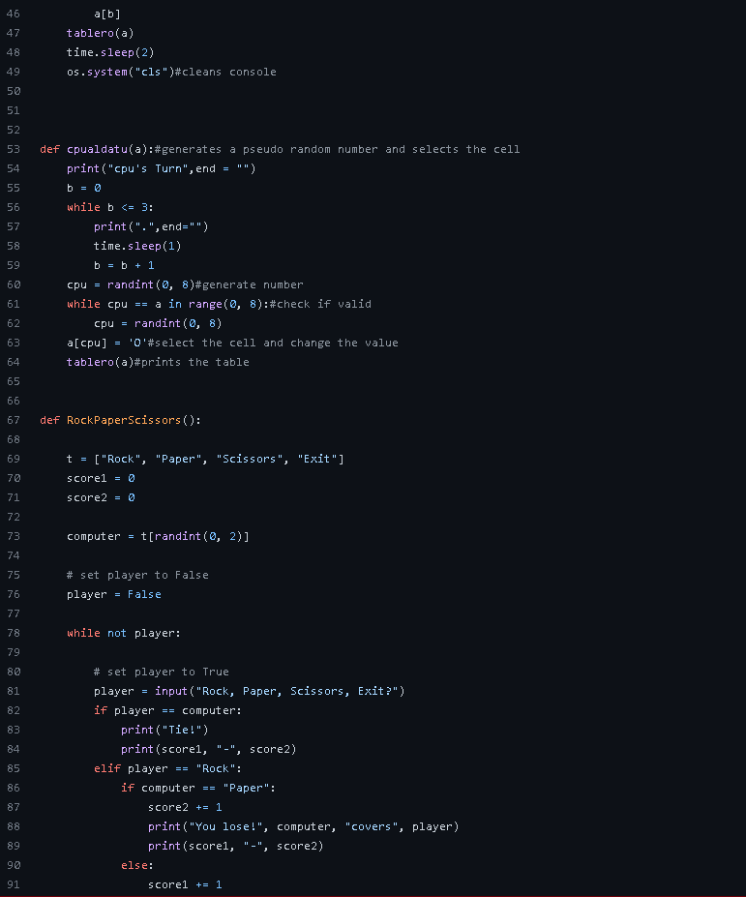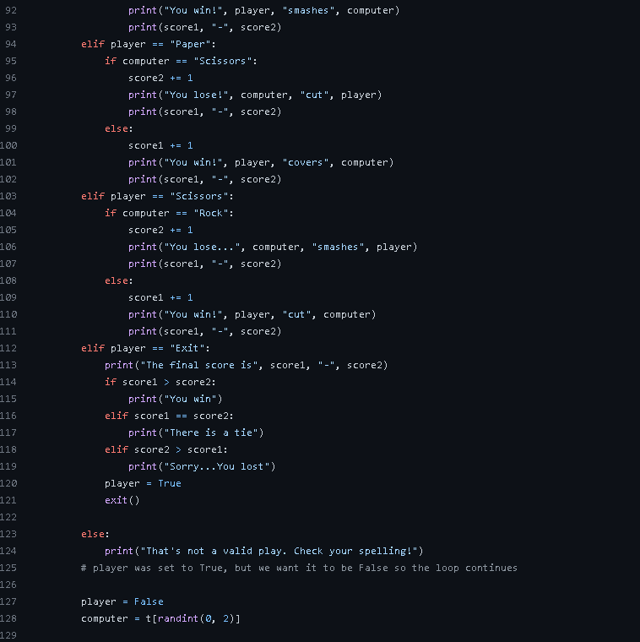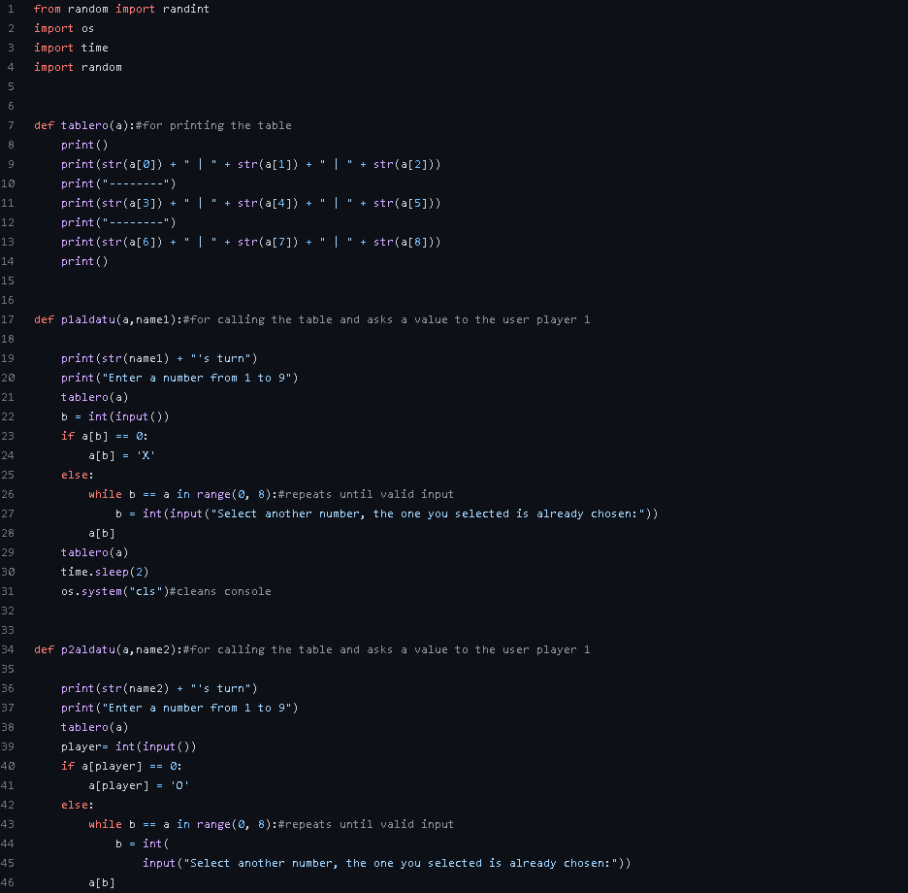

Aiert created a tic TAC toe using random ints and functions, the tablero function prints the table to play, the player 1&2 change the lista used to store the values(player 1 =X and 2 = O)

While the CPU generales a pseudo random number and uses that namber to change the list(values =O)

Aierten partia:

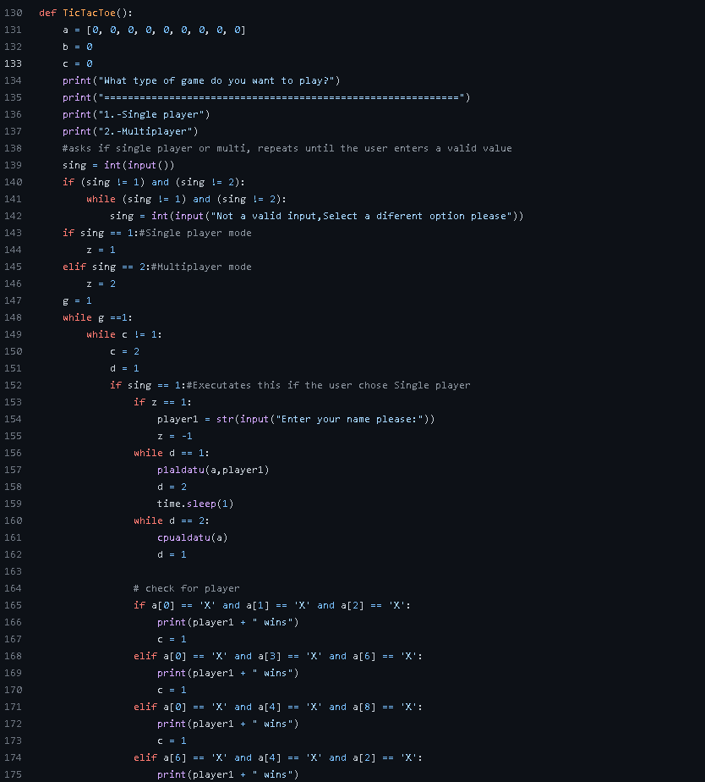

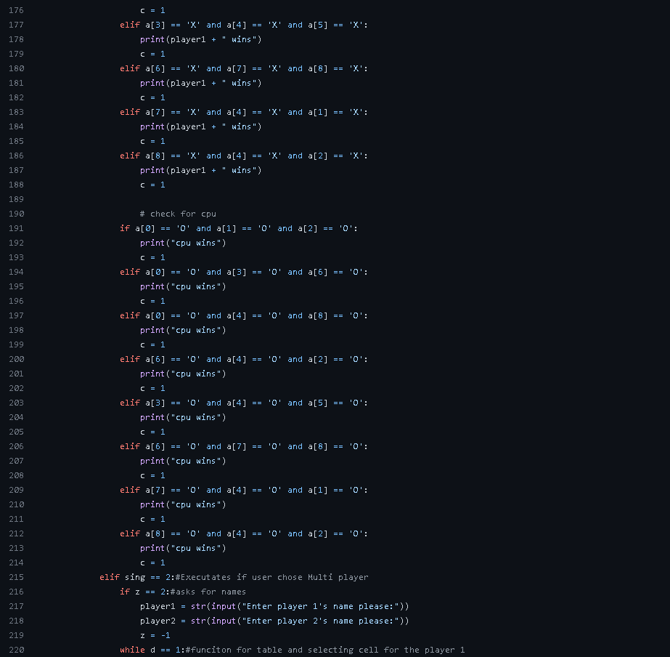

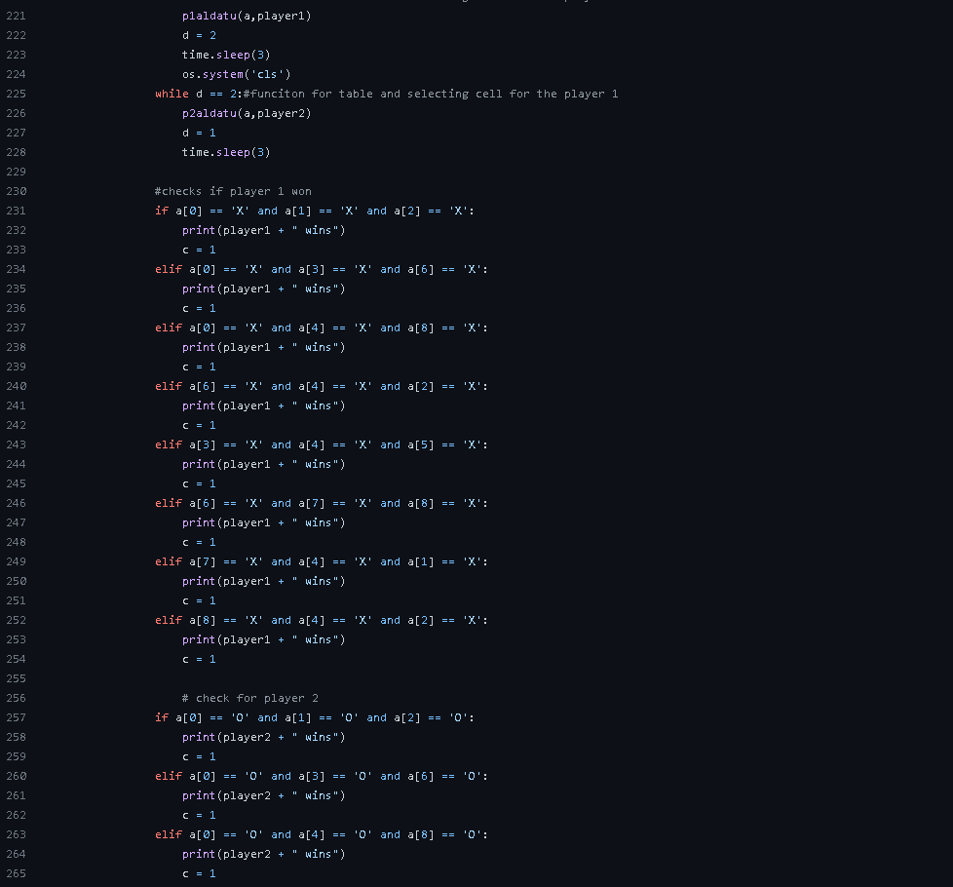

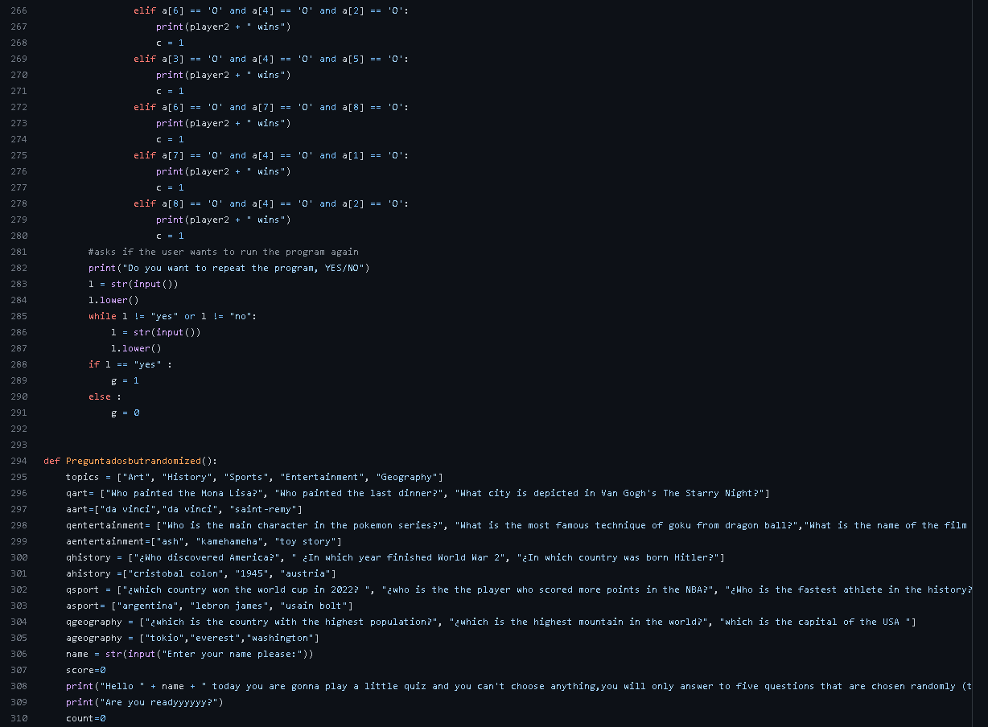

Julen created a quiz with random questions and themes that are based on a number generated by the computer

julenen partia: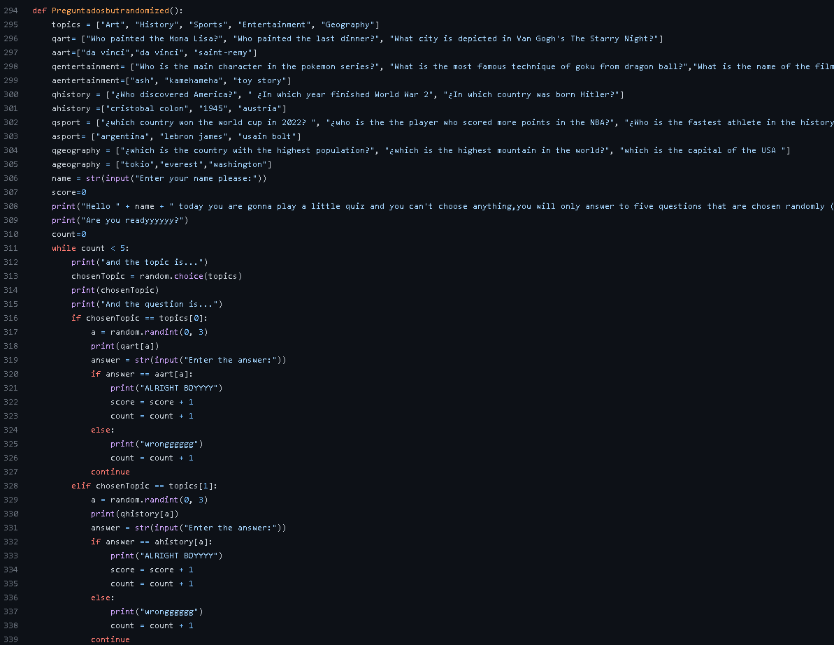

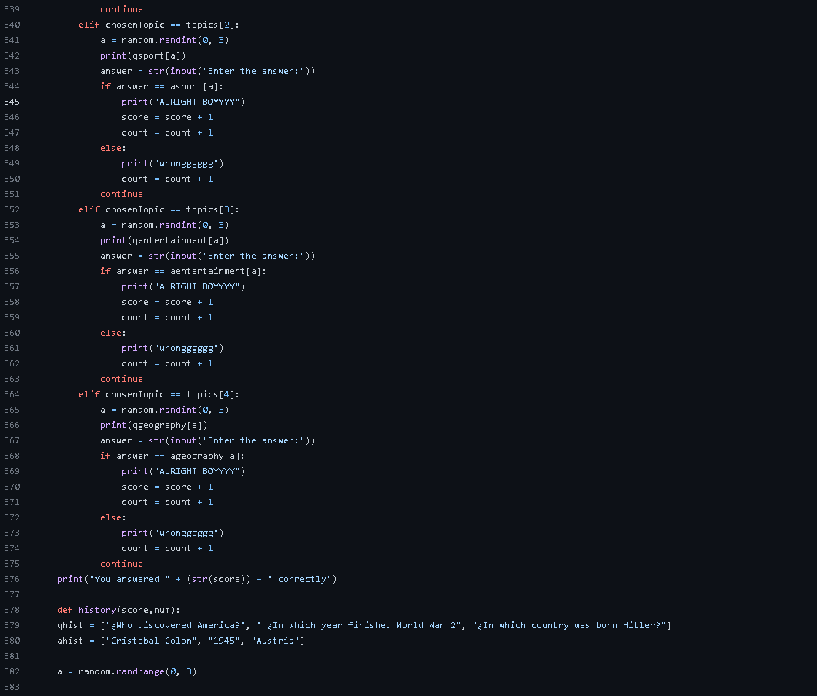

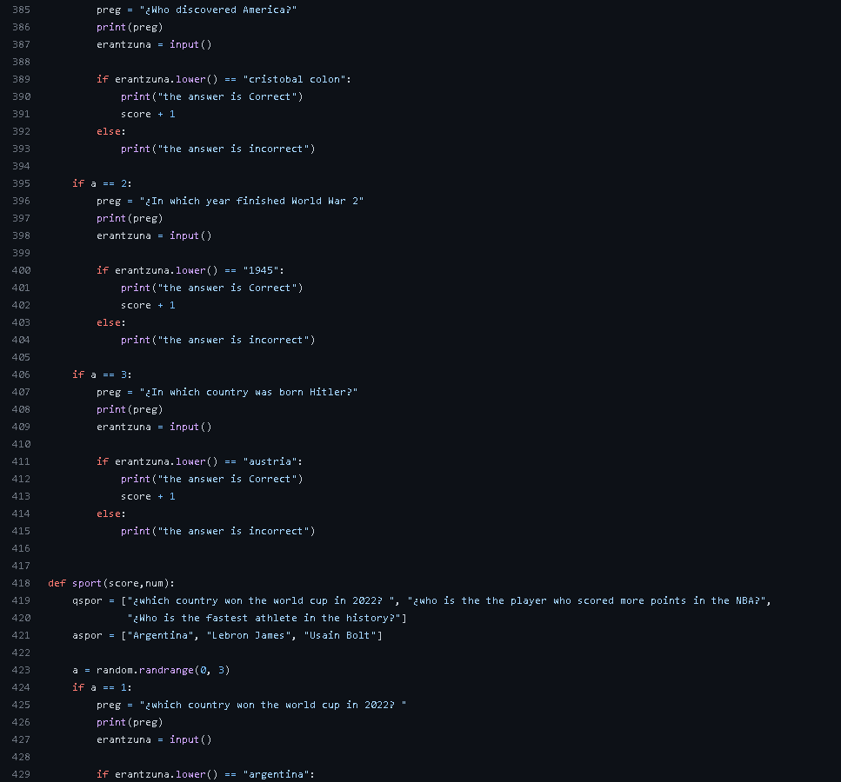

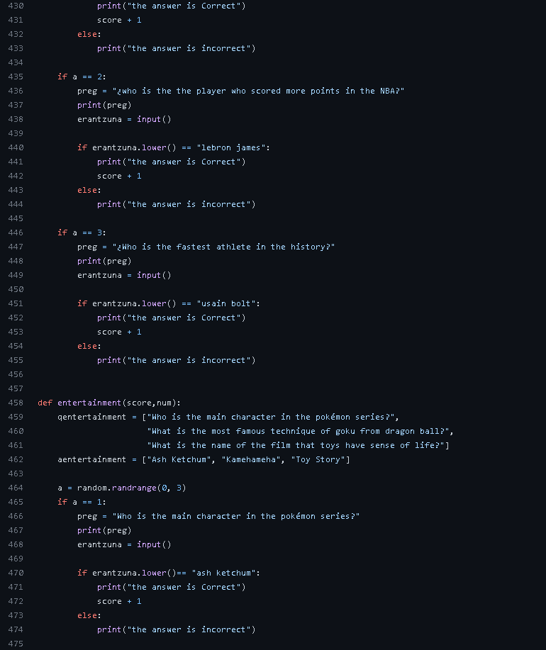

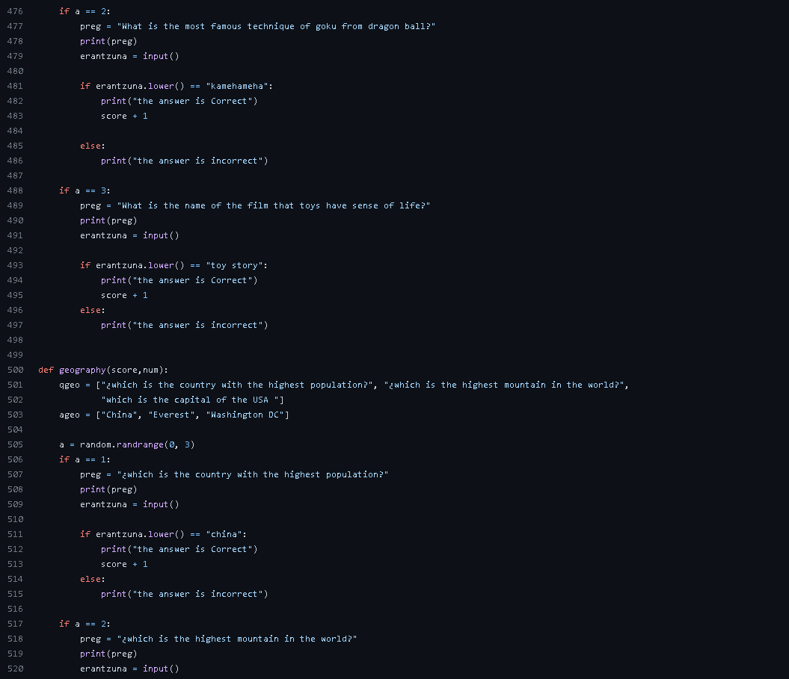

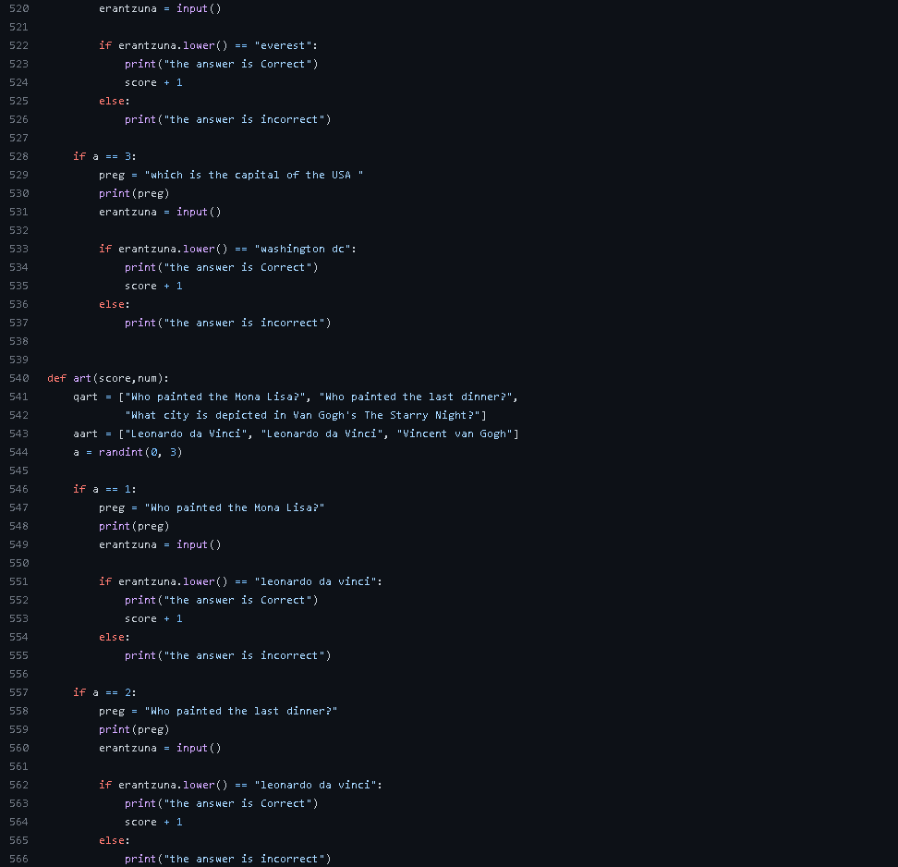

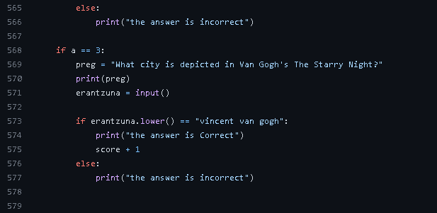

Iker created a quiz project using lists,but instead of being randomized It asks values to the user depending what he wantsto play

IKERREN PARTIA:

